Kibana Logs Queries

Kibana Portal can be accessed from Elastic Console → Analytics → Discover

On top left we have metrics-* & logs-*

Select logs-* and run the query as

*container.labels.com_docker_swarm_service_name: "flask"*

*http.response.status_code: 403 or 404*

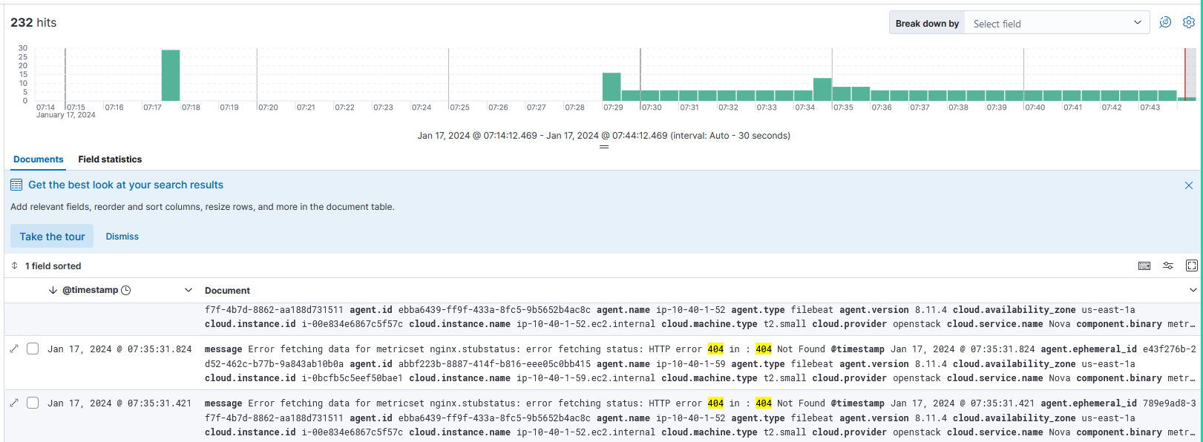

*log.file.path : "/var/log/nginx/access.log" and http.response.status_code: 403*

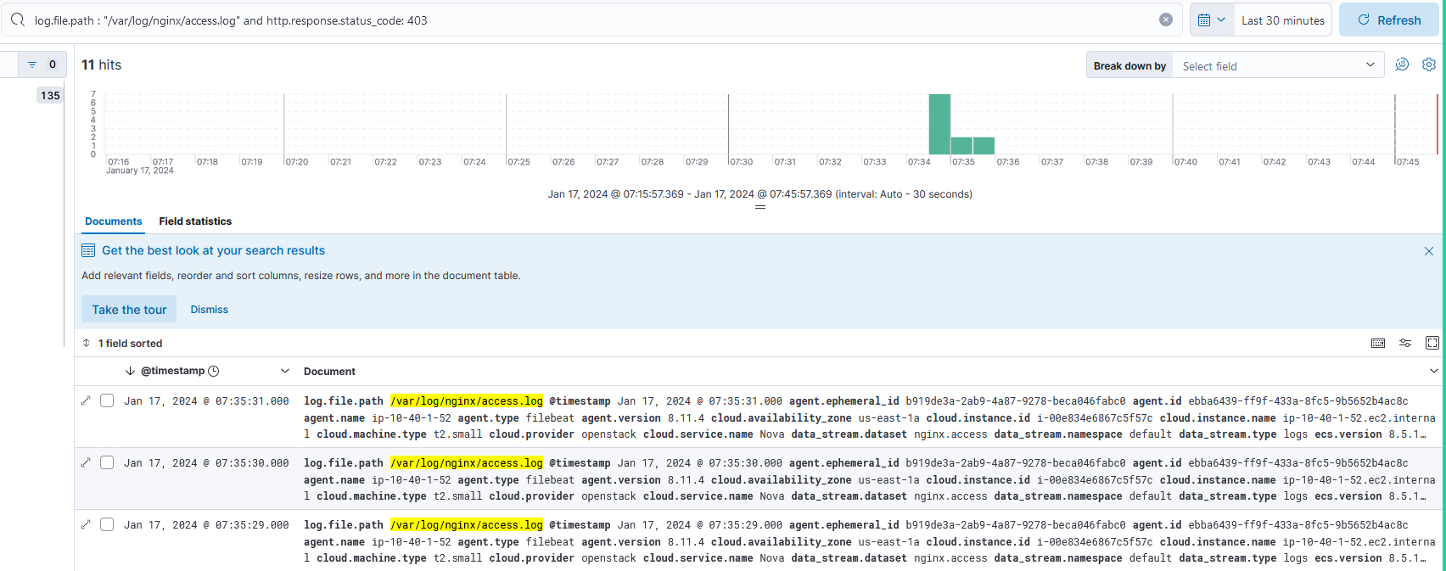

Error codes can be searched in logs: error.code : 404 or 304 or 200 or 40*

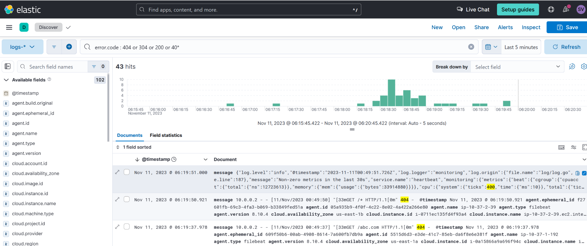

**Collecting Nginx Logs Using Filebeat:**

We need to add Nginx Integration for the agent policy as shown below. In this case I am adding to DevSecOpsB37-Policy. As you can see in the picture we only have docker and system integrations.

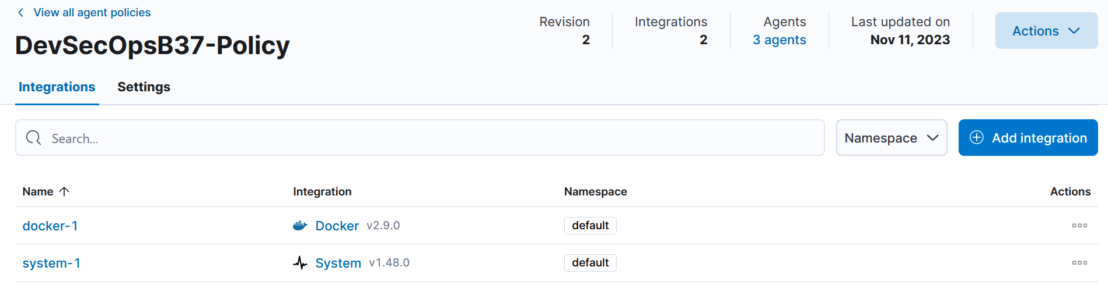

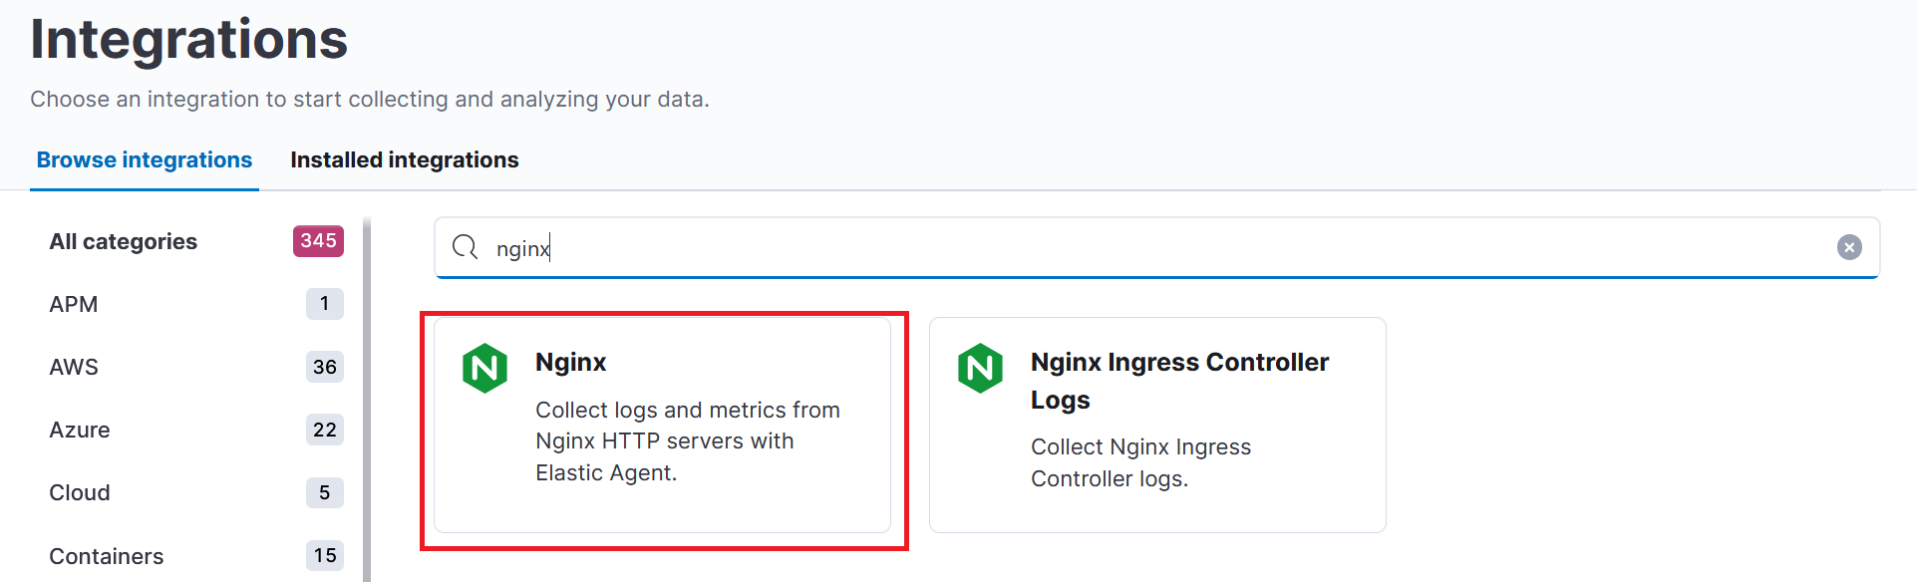

Click on **Add Nginx** on the next screen.

